**QUIZ # 2**

|  |  |
| --- | --- |
| NAME : | ROLL NO. # |

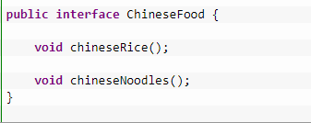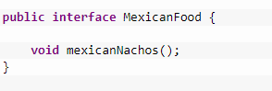

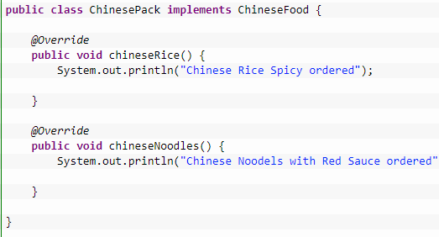

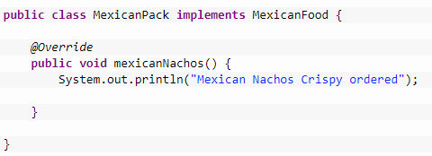

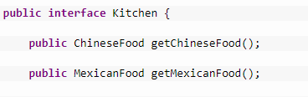

}

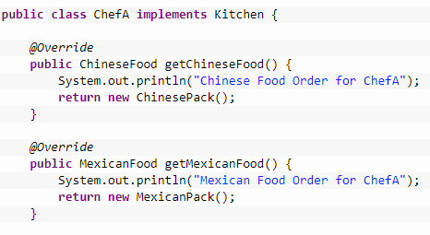

}

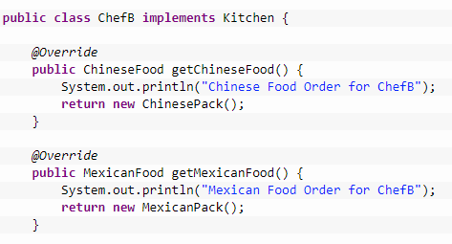

}

**Q1:** Identify the design pattern used in above coded solution. Mention Entity – Class pairing. (5)

**Q2:** Draw complete Diagram for the above mentioned solution based on the used design pattern. (5)

**Solution**

**Q1**:

Entity-Class Pairing:

Abstract Factory 🡪 Kitchen

Concrete Factory 🡪 ChefA, ChefB

Abstract Product 🡪 ChineseFood, MexicanFood

Concrete Product 🡪 ChinesePackByChefA, ChinesePackByChefB, MexicanPackByChefA, MexicanPackByChefB

**Q2**:

